
Subject: Programming with Java
ASSIGNMENT No : 24
TITLE: Develop a Java GUI application integrated with JDBC to perform database operations.

Name: Avdhoot Mohite Class: CSE A2
PRN: 25070122056 Batch:25-29

Problem Statement
Develop a Java GUI application integrated with JDBC to perform database operations."

Learning Objectives
To integrate Java GUI applications with databases using JDBC.

Theory
Java Swing provides graphical user interface components such as buttons, labels, text fields, tables, and forms, while JDBC enables database connectivity. Combining Swing with JDBC allows developers to create interactive desktop applications capable of performing database operations through a graphical interface. Users can enter information using GUI components, which is then processed and stored in the database using SQL queries. Retrieved records can be displayed in tables or text fields for easy viewing and modification. This integration improves user experience by eliminating command-line interaction and forms the foundation of desktop applications such as inventory management systems, library management systems, and student management systems.

Exercise
- Create a Library Management System GUI connected with database
CODE:
import java.awt.*;
import java.sql.*;
import javax.swing.*;
import javax.swing.table.DefaultTableModel;

public class assignment24a extends JFrame {

JTextField idField, titleField, authorField, quantityField;
JTable table;
DefaultTableModel model;

String url = "jdbc:mysql://localhost:3306/library_db";
String user = "root";
String password = "Avdrocks@0504";

assignment24a() {
setTitle("Library Management System");
setSize(750, 500);
setDefaultCloseOperation(JFrame.EXIT_ON_CLOSE);
setLocationRelativeTo(null);

JPanel form = new JPanel(new GridLayout(4, 2, 10, 10));
form.setBorder(BorderFactory.createEmptyBorder(15, 15, 15, 15));

idField = new JTextField();
titleField = new JTextField();
authorField = new JTextField();
quantityField = new JTextField();

form.add(new JLabel("Book ID:"));
form.add(idField);
form.add(new JLabel("Book Title:"));
form.add(titleField);
form.add(new JLabel("Author:"));
form.add(authorField);
form.add(new JLabel("Quantity:"));
form.add(quantityField);

JPanel buttons = new JPanel();

JButton add = new JButton("Add");
JButton view = new JButton("View");
JButton update = new JButton("Update");
JButton delete = new JButton("Delete");

buttons.add(add);
buttons.add(view);
buttons.add(update);
buttons.add(delete);

model = new DefaultTableModel(
new String[]{"Book ID", "Title", "Author", "Quantity"}, 0
);

table = new JTable(model);

JPanel top = new JPanel(new BorderLayout());
top.add(form, BorderLayout.CENTER);
top.add(buttons, BorderLayout.SOUTH);

add(top, BorderLayout.NORTH);
add(new JScrollPane(table), BorderLayout.CENTER);

add.addActionListener(e -> executeOperation("INSERT"));
view.addActionListener(e -> loadBooks());
update.addActionListener(e -> executeOperation("UPDATE"));
delete.addActionListener(e -> executeOperation("DELETE"));

table.getSelectionModel().addListSelectionListener(e -> {
if (!e.getValueIsAdjusting() && table.getSelectedRow() >= 0) {
int r = table.getSelectedRow();
idField.setText(model.getValueAt(r, 0).toString());
titleField.setText(model.getValueAt(r, 1).toString());
authorField.setText(model.getValueAt(r, 2).toString());
quantityField.setText(model.getValueAt(r, 3).toString());
}
});

loadBooks();
setVisible(true);
}

Connection connect() throws SQLException {
return DriverManager.getConnection(url, user, password);
}

void executeOperation(String operation) {
String sql = "";

if (operation.equals("INSERT"))
sql = "INSERT INTO books VALUES (?, ?, ?, ?)";
else if (operation.equals("UPDATE"))
sql = "UPDATE books SET title=?, author=?, quantity=? WHERE book_id=?";
else if (operation.equals("DELETE"))
sql = "DELETE FROM books WHERE book_id=?";

try (Connection con = connect();
PreparedStatement ps = con.prepareStatement(sql)) {

int id = Integer.parseInt(idField.getText().trim());

if (operation.equals("INSERT")) {
ps.setInt(1, id);
ps.setString(2, titleField.getText());
ps.setString(3, authorField.getText());
ps.setInt(4, Integer.parseInt(quantityField.getText().trim()));
} else if (operation.equals("UPDATE")) {
ps.setString(1, titleField.getText());
ps.setString(2, authorField.getText());
ps.setInt(3, Integer.parseInt(quantityField.getText().trim()));
ps.setInt(4, id);
} else {
ps.setInt(1, id);
}

int rows = ps.executeUpdate();

JOptionPane.showMessageDialog(this,
rows > 0 ? "Operation Successful!" : "Book not found!");

loadBooks();

} catch (SQLException | NumberFormatException ex) {
JOptionPane.showMessageDialog(this, ex.getMessage());
}
}

void loadBooks() {
model.setRowCount(0);

try (Connection con = connect();
Statement stmt = con.createStatement();
ResultSet rs = stmt.executeQuery(
"SELECT * FROM books ORDER BY book_id")) {

while (rs.next()) {
model.addRow(new Object[]{
rs.getInt("book_id"),
rs.getString("title"),
rs.getString("author"),
rs.getInt("quantity")
});
}

} catch (SQLException ex) {
JOptionPane.showMessageDialog(this, ex.getMessage());
}
}

public static void main(String[] args) {
SwingUtilities.invokeLater(() -> new assignment24a());
}
}

DATABASE:
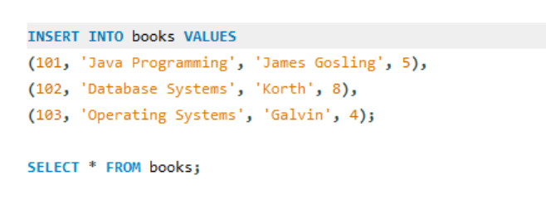
OUTPUT:
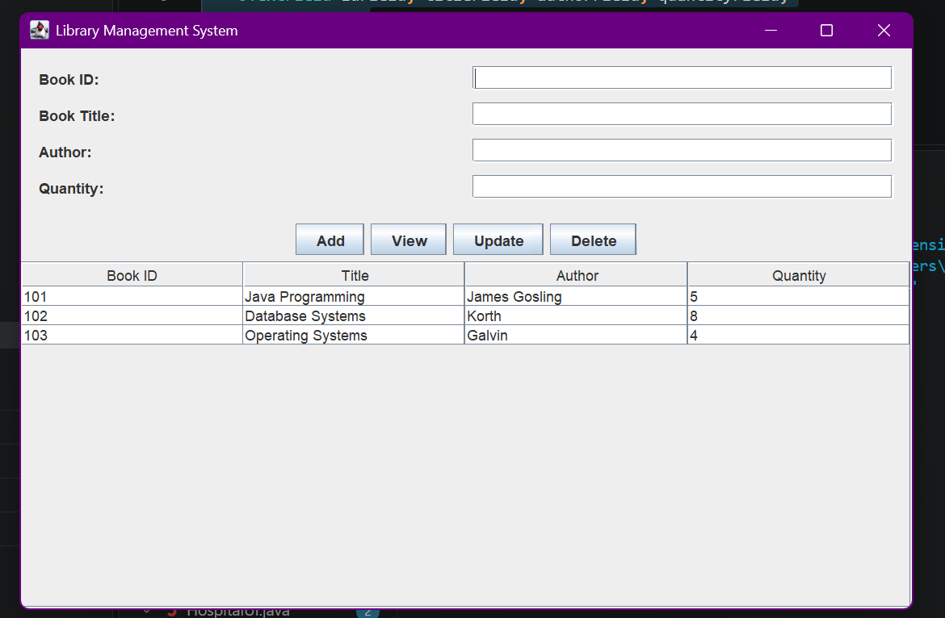
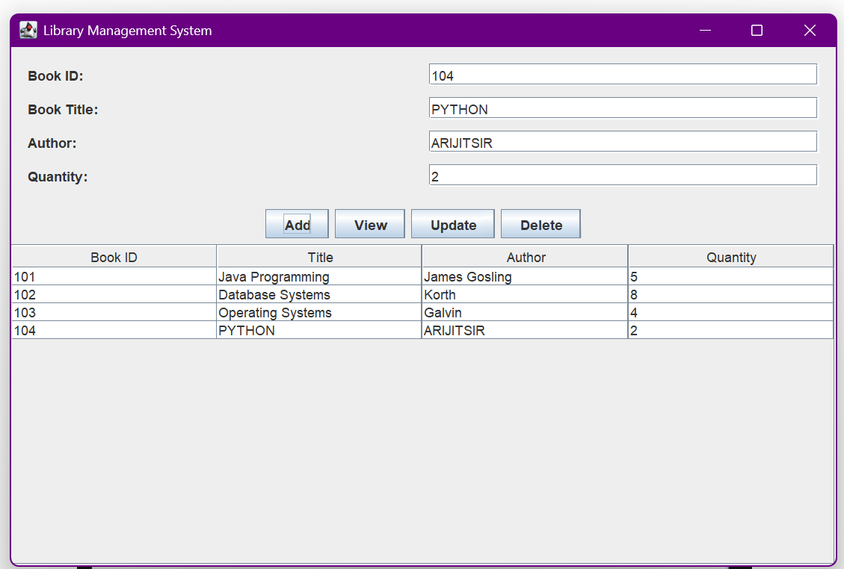
- Create a Book Issue Tracking System GUI application using Java Swing connected to a database. The system should store book ID, student name, issue date, and return date, and allow record management.
CODE:
import java.awt.*;
import java.sql.*;
import javax.swing.*;
import javax.swing.table.DefaultTableModel;

public class assignment24b extends JFrame {

JTextField issueIdField, bookIdField, studentField;
JTextField issueDateField, returnDateField;
JTable table;
DefaultTableModel model;

String url = "jdbc:mysql://localhost:3306/library_db";
String user = "root";
String password = "Avdrocks@0504";

assignment24b() {
setTitle("Book Issue Tracking System");
setSize(850, 550);
setDefaultCloseOperation(JFrame.EXIT_ON_CLOSE);
setLocationRelativeTo(null);

JPanel form = new JPanel(new GridLayout(5, 2, 10, 10));
form.setBorder(BorderFactory.createEmptyBorder(15, 15, 15, 15));

issueIdField = new JTextField();
issueIdField.setEditable(false);
bookIdField = new JTextField();
studentField = new JTextField();
issueDateField = new JTextField();
returnDateField = new JTextField();

form.add(new JLabel("Issue ID (Auto):"));
form.add(issueIdField);
form.add(new JLabel("Book ID:"));
form.add(bookIdField);
form.add(new JLabel("Student Name:"));
form.add(studentField);
form.add(new JLabel("Issue Date (YYYY-MM-DD):"));
form.add(issueDateField);
form.add(new JLabel("Return Date (YYYY-MM-DD):"));
form.add(returnDateField);

JButton addBtn = new JButton("Add Issue");
JButton viewBtn = new JButton("View Issues");
JButton updateBtn = new JButton("Update");
JButton deleteBtn = new JButton("Delete");

JPanel buttons = new JPanel();
buttons.add(addBtn);
buttons.add(viewBtn);
buttons.add(updateBtn);
buttons.add(deleteBtn);

model = new DefaultTableModel(
new String[]{"Issue ID", "Book ID", "Student", "Issue Date", "Return Date"}, 0
);

table = new JTable(model);

JPanel top = new JPanel(new BorderLayout());
top.add(form, BorderLayout.CENTER);
top.add(buttons, BorderLayout.SOUTH);

add(top, BorderLayout.NORTH);
add(new JScrollPane(table), BorderLayout.CENTER);

addBtn.addActionListener(e -> saveIssue("INSERT"));
viewBtn.addActionListener(e -> loadIssues());
updateBtn.addActionListener(e -> saveIssue("UPDATE"));
deleteBtn.addActionListener(e -> saveIssue("DELETE"));

table.getSelectionModel().addListSelectionListener(e -> {
if (!e.getValueIsAdjusting() && table.getSelectedRow() >= 0) {
int r = table.getSelectedRow();
issueIdField.setText(model.getValueAt(r, 0).toString());
bookIdField.setText(model.getValueAt(r, 1).toString());
studentField.setText(model.getValueAt(r, 2).toString());
issueDateField.setText(model.getValueAt(r, 3).toString());
returnDateField.setText(model.getValueAt(r, 4).toString());
}
});

loadIssues();
setVisible(true);
}

Connection connect() throws SQLException {
return DriverManager.getConnection(url, user, password);
}

void saveIssue(String operation) {
String sql;

if (operation.equals("INSERT"))
sql = "INSERT INTO book_issues (book_id, student_name, issue_date, return_date) VALUES (?, ?, ?, ?)";
else if (operation.equals("UPDATE"))
sql = "UPDATE book_issues SET book_id=?, student_name=?, issue_date=?, return_date=? WHERE issue_id=?";
else
sql = "DELETE FROM book_issues WHERE issue_id=?";

try (Connection con = connect();
PreparedStatement ps = con.prepareStatement(sql)) {

if (!operation.equals("DELETE")) {
ps.setInt(1, Integer.parseInt(bookIdField.getText().trim()));
ps.setString(2, studentField.getText());
ps.setDate(3, java.sql.Date.valueOf(issueDateField.getText().trim()));
ps.setDate(4, java.sql.Date.valueOf(returnDateField.getText().trim()));
}

if (operation.equals("UPDATE"))
ps.setInt(5, Integer.parseInt(issueIdField.getText().trim()));

if (operation.equals("DELETE"))
ps.setInt(1, Integer.parseInt(issueIdField.getText().trim()));

int rows = ps.executeUpdate();

JOptionPane.showMessageDialog(this,
rows > 0 ? "Operation Successful!" : "Record not found!");

loadIssues();

} catch (SQLException | IllegalArgumentException ex) {
JOptionPane.showMessageDialog(this, ex.getMessage());
}
}

void loadIssues() {
model.setRowCount(0);

try (Connection con = connect();
Statement stmt = con.createStatement();
ResultSet rs = stmt.executeQuery(
"SELECT * FROM book_issues ORDER BY issue_id")) {

while (rs.next()) {
model.addRow(new Object[]{
rs.getInt("issue_id"),
rs.getInt("book_id"),
rs.getString("student_name"),
rs.getDate("issue_date"),
rs.getDate("return_date")
});
}

} catch (SQLException ex) {
JOptionPane.showMessageDialog(this, ex.getMessage());
}
}

public static void main(String[] args) {
SwingUtilities.invokeLater(() -> new assignment24b());
}
}

DATABASE:
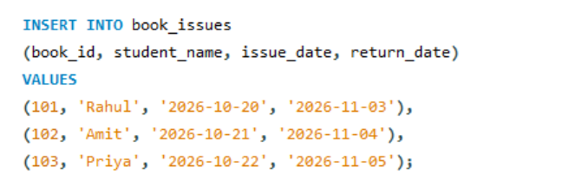
OUTPUT:
